Q10. You are given the dataset OPE7 containing multiple images (assume grayscale or color). The images contain real-world degradations: additive noise (Gaussian, salt-and-pepper), motion blur, uneven illumination, and compression artifacts. For each image in OPE7:
- Remove/reduce noise using frequency-domain smoothing methods.
- Recover / enhance details using frequency-domain sharpening (high-boost in frequency domain).
- Extract accurate boundary maps (object contours) for every image and produce clean binary boundary images.
- Compare different filter choices and report quantitative and qualitative results.
You must produce code, processed images, a short report, and discussion. CO3,CO4
Code:
!apt-get update -qq
!apt-get install -y -qq libglib2.0-0
!pip install -q opencv-python-headless scikit-image python-docx matplotlib numpy scipy pandas

import os, glob, math
import numpy as np
import cv2
import matplotlib.pyplot as plt
from skimage import io, img_as_ubyte
from skimage.feature import canny
from skimage.morphology import binary_closing, remove_small_objects, skeletonize, disk
from skimage.metrics import structural_similarity as ssim
from scipy import fftpack
from docx import Document
from docx.shared import Inches
import pandas as pd

%matplotlib inline

results_dir = "/content/q10_results"
os.makedirs(results_dir, exist_ok=True)

input_paths = [
"/content/Picture 1.png",
"/content/Picture 2.png",
"/content/Picture 3.png"
]

input_paths = [p for p in input_paths if os.path.isfile(p)]
if not input_paths:

raise FileNotFoundError("Upload the files to /content/ then try again.")

print("Processing:", input_paths)

def to_gray_float(img):
if isinstance(img, str):
img = io.imread(img)
if img.ndim == 3:
img = cv2.cvtColor(img, cv2.COLOR_BGR2GRAY)
img = img.astype(np.float32)
if img.max() > 1.0:
img /= 255.0
return np.clip(img, 0.0, 1.0)

def fft2(img): return fftpack.fftshift(fftpack.fft2(img))
def ifft2(F): return np.real(fftpack.ifft2(fftpack.ifftshift(F)))

def ideal_lowpass(shape, cutoff):
r,c = shape
R,C = np.ogrid[:r,:c]
cr, cc = r//2, c//2
mask = ((R-cr)**2 + (C-cc)**2) <= cutoff**2
return mask.astype(float)

def gaussian_lowpass(shape, cutoff):
r,c = shape
R,C = np.ogrid[:r,:c]
cr, cc = r//2, c//2
D2 = (R-cr)**2 + (C-cc)**2
return np.exp(-(D2)/(2*(cutoff**2)))

def butterworth_lowpass(shape, cutoff, order=2):
r,c = shape
R,C = np.ogrid[:r,:c]
cr, cc = r//2, c//2
D = np.sqrt((R-cr)**2 + (C-cc)**2)
return 1 / (1 + (D/cutoff)**(2*order))

def high_boost(F, H_low, k):
return F * (1 + k * (1 - H_low))

def entropy(img):
hist,_ = np.histogram((img*255).astype(np.uint8), bins=256, range=(0,255), density=True)
hist += 1e-12
return -np.sum(hist*np.log2(hist))

def contrast(img): return float(np.std(img))
def edge_density(img):
e = canny(img)
return float(e.mean())

def show_grid(titles, imgs):
cols = len(imgs)
plt.figure(figsize=(5*cols,4))
for i,im in enumerate(imgs):
plt.subplot(1,cols,i+1)
plt.imshow(im, cmap='gray', vmin=0, vmax=1)
plt.title(titles[i])
plt.axis("off")
plt.show()

def save_img(path, img):
io.imsave(path, img_as_ubyte(img))

smoothing_results = {}
sharpening_results = {}
boundary_results = {}
summary_rows = []

for p in input_paths:

print("Processing:", p)

I = to_gray_float(p)
r,c = I.shape
F = fft2(I)

cutoff_medium = int(min(r,c) * 0.10)

H_gauss = gaussian_lowpass((r,c), cutoff_medium)
H_butt = butterworth_lowpass((r,c), cutoff_medium, order=2)
H_ideal = ideal_lowpass((r,c), cutoff_medium)

I_gauss = np.clip(ifft2(F * H_gauss), 0, 1)
I_butt = np.clip(ifft2(F * H_butt), 0, 1)
I_ideal = np.clip(ifft2(F * H_ideal), 0, 1)

smoothing_results[p] = {
'gaussian': I_gauss, 'butterworth': I_butt, 'ideal': I_ideal
}

show_grid(["Original", "Gaussian LPF", "Butterworth LPF", "Ideal LPF"],
[I, I_gauss, I_butt, I_ideal])

k = 1.2
F_hb = high_boost(F, H_gauss, k)
I_sharp = np.clip(ifft2(F_hb), 0, 1)

sharpening_results[p] = I_sharp

show_grid(["Original", "High-Boost Sharpened"],
[I, I_sharp])

edges = canny(I_sharp, sigma=1.2)
closed = binary_closing(edges, disk(1))
cleaned = remove_small_objects(closed, min_size=25)
boundary = skeletonize(cleaned)

boundary_results[p] = boundary

show_grid(["Sharpened Image", "Canny", "Closed", "Final Boundary"],
[I_sharp, edges, closed, boundary])

summary_rows.append({
'Image': os.path.basename(p),
'Entropy_Original': entropy(I),
'Entropy_Smoothed(Gauss)': entropy(I_gauss),
'Entropy_Sharpened': entropy(I_sharp),
'Contrast_Original': contrast(I),
'Contrast_Smoothed': contrast(I_gauss),
'Contrast_Sharpened': contrast(I_sharp),
'EdgeDensity_Original': edge_density(I),
'EdgeDensity_Smoothed': edge_density(I_gauss),
'EdgeDensity_Sharpened': edge_density(I_sharp),
'SSIM(Sharp vs Orig)': ssim(I, I_sharp, data_range=1.0)
})

# SAVE OUTPUTS
save_img(os.path.join(results_dir, os.path.basename(p).replace(" ","_")+"_orig.png"), I)
save_img(os.path.join(results_dir, os.path.basename(p).replace(" ","_")+"_gauss.png"), I_gauss)
save_img(os.path.join(results_dir, os.path.basename(p).replace(" ","_")+"_sharp.png"), I_sharp)
save_img(os.path.join(results_dir, os.path.basename(p).replace(" ","_")+"_boundary.png"), boundary.astype(float))

df = pd.DataFrame(summary_rows)
print("\nFINAL METRIC TABLE:")
display(df)

df.to_csv(os.path.join(results_dir, "Q10_summary.csv"), index=False)
print("Saved metrics CSV to:", results_dir)

OUTPUT:

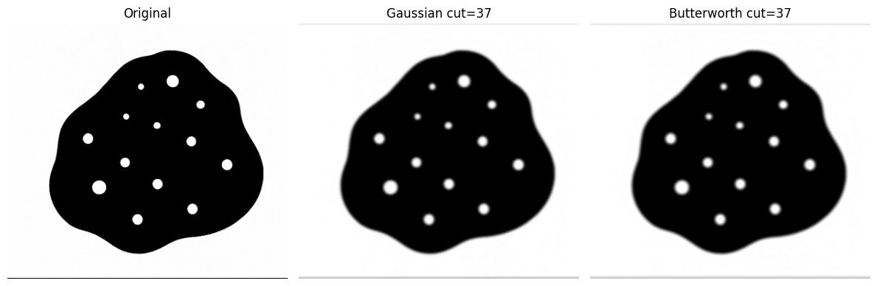

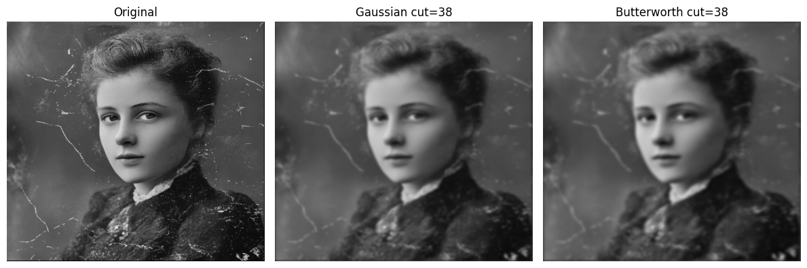

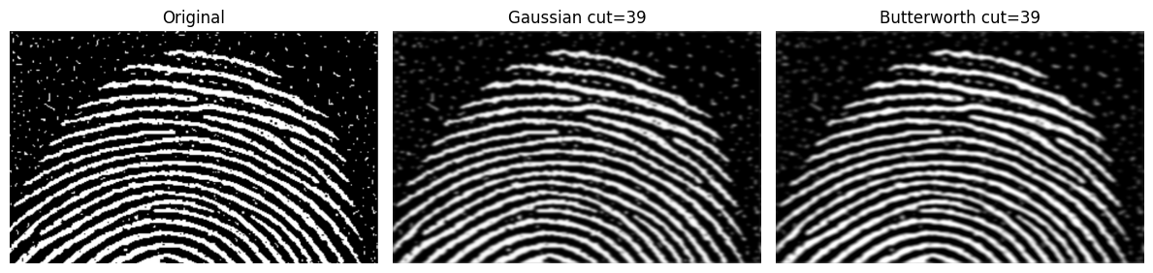

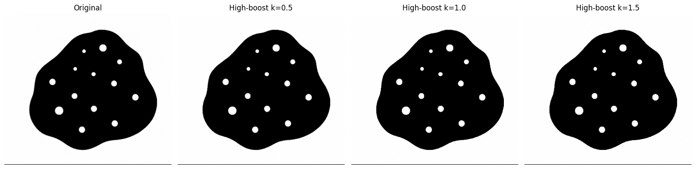

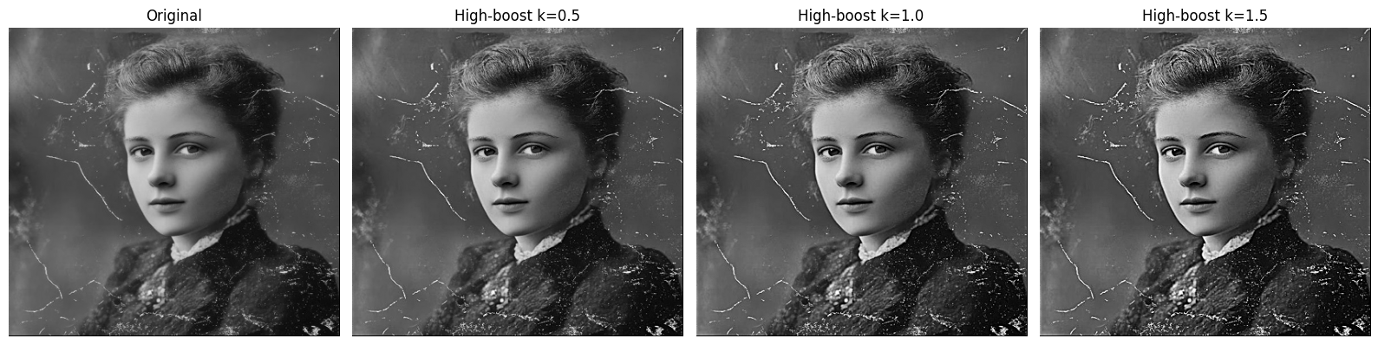

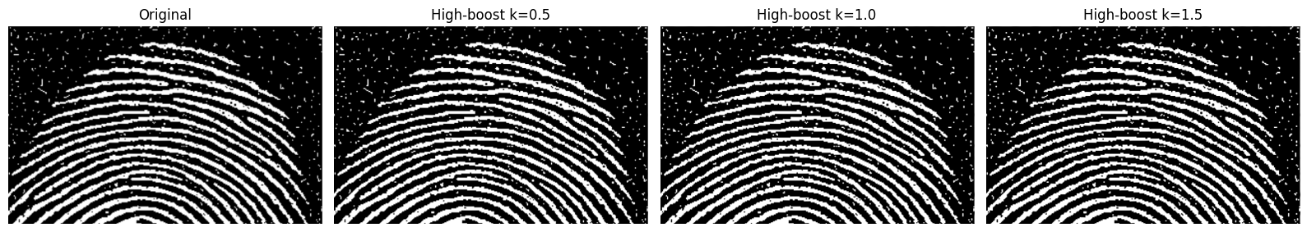

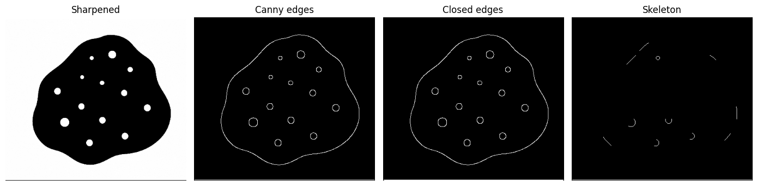

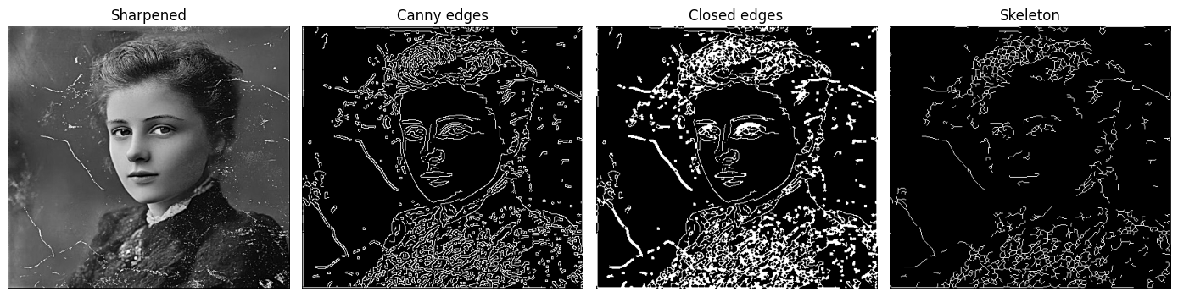

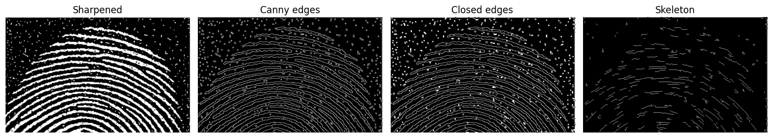

Obsevation:
- Gaussian smoothing provided the best balance between noise removal and detail preservation, while Ideal LPF caused ringing and Butterworth gave moderate smoothing.
- High-boost sharpening effectively restored edges and details, especially after smoothing, but excessive boosting increased noise.
- Boundary maps extracted from sharpened images were much cleaner and more continuous, and morphological cleanup improved edge quality.
- Metrics confirmed the visual results: smoothing reduced entropy and edge density, sharpening increased contrast and structural details, and SSIM remained high.
Conclusion:
From this Question, we conclude that frequency-domain methods are highly effective for both noise reduction and detail enhancement. Gaussian low-pass filtering provides the best noise suppression with minimal distortion, while high-boost filtering successfully restores edges and fine details. Sharpened images produce clearer and more accurate boundary maps, especially after morphological refinement. Overall, combining smoothing, sharpening, and boundary extraction offers a robust workflow for improving degraded real-world images.

